**CASE STUDY - 2**

**ZEN CLASS**

**Zen Class Details:**

Design database for Zen class programme

* users
* codekata
* attendance
* topics
* tasks
* company_drives
* mentors

Database Creation:

show dbs

use zen_class

db.createCollection(“users”)

db.users.insertMany([

{ userid: 1, name: 'Boobathi', email: 'boobathi@gmail.com', mentor: 'Sathish' },

{ userid: 2, name: 'Mani', email: 'mani@gmail.com', mentor: 'Nagaraj' },

{ userid: 3, name: 'Karthi', email: 'karthi@gmail.com', mentor: 'Sathish' },

{ userid: 4, name: 'Dharshini', email: 'dharshini@gmail.com', mentor: 'Rupan' },

{ userid: 5, name: 'Balu', email: 'balu@gmail.com', mentor: 'Sathish' }

])

db.createCollection("codekata")

db.codekata.insertMany([

{ user_id: 1, codekata_solved: 300, webkata_solved: 50 },

{ user_id: 2, codekata_solved: 250, webkata_solved: 90 },

{ user_id: 3, codekata_solved: 200, webkata_solved: 50 },

{ user_id: 4, codekata_solved: 190, webkata_solved: 90 },

{ user_id: 5, codekata_solved: 180, webkata_solved: 100 }

])

db.createCollection("attendance")

db.attendance.insertMany([{

"userid":1,

"Class_date":ISODate("2023-10-07"),

"attendance":true

},

{

"userid":1,

"Class_date":ISODate("2023-10-08"),

"attendance":true

},

{

"userid":1,

"Class_date":ISODate("2023-10-14"),

"attendance":true

},

{

"userid":1,

"Class_date":ISODate("2023-10-15"),

"attendance":true

},

{

"userid":1,

"Class_date":ISODate("2023-10-21"),

"attendance":true

},

{

"userid":1,

"Class_date":ISODate("2023-10-22"),

"attendance":true

},

{

"userid":1,

"Class_date":ISODate("2023-10-28"),

"attendance":true

},

{

"userid":1,

"Class_date":ISODate("2023-10-29"),

"attendance":true

},

{

"userid":1,

"Class_date":ISODate("2023-11-05"),

"attendance":true

},

{

"userid":1,

"Class_date":ISODate("2023-11-06"),

"attendance":true

},

{

"userid":2,

"Class_date":ISODate("2023-10-07"),

"attendance":true

},

{

"userid":2,

"Class_date":ISODate("2023-10-08"),

"attendance":true

},

{

"userid":2,

"Class_date":ISODate("2023-10-14"),

"attendance":true

},

{

"userid":2,

"Class_date":ISODate("2023-10-15"),

"attendance":false

},

{

"userid":2,

"Class_date":ISODate("2023-10-21"),

"attendance":true

},

{

"userid":2,

"Class_date":ISODate("2023-10-22"),

"attendance":true

},

{

"userid":2,

"Class_date":ISODate("2023-10-28"),

"attendance":true

},

{

"userid":2,

"Class_date":ISODate("2023-10-29"),

"attendance":true

},

{

"userid":2,

"Class_date":ISODate("2023-11-05"),

"attendance":true

},

{

"userid":2,

"Class_date":ISODate("2023-11-06"),

"attendance":false

},

{

"userid":3,

"Class_date":ISODate("3023-10-07"),

"attendance":true

},{

"userid":3,

"Class_date":ISODate("2023-10-08"),

"attendance":true

},

{

"userid":3,

"Class_date":ISODate("2023-10-14"),

"attendance":true

},

{

"userid":3,

"Class_date":ISODate("2023-10-15"),

"attendance":false

},

{

"userid":3,

"Class_date":ISODate("2023-10-21"),

"attendance":true

},

{

"userid":3,

"Class_date":ISODate("2023-10-22"),

"attendance":true

},

{

"userid":3,

"Class_date":ISODate("2023-10-28"),

"attendance":true

},

{

"userid":3,

"Class_date":ISODate("2023-10-29"),

"attendance":true

},

{

"userid":3,

"Class_date":ISODate("2023-11-05"),

"attendance":true

},

{

"userid":3,

"Class_date":ISODate("2023-11-06"),

"attendance":false

},

{

"userid":4,

"Class_date":ISODate("2023-10-07"),

"attendance":true

},

{

"userid":4,

"Class_date":ISODate("2023-10-08"),

"attendance":true

},

{

"userid":4,

"Class_date":ISODate("2023-10-14"),

"attendance":true

},

{

"userid":4,

"Class_date":ISODate("2023-10-15"),

"attendance":true

},

{

"userid":4,

"Class_date":ISODate("2023-10-21"),

"attendance":true

},

{

"userid":4,

"Class_date":ISODate("2023-10-22"),

"attendance":true

},

{

"userid":4,

"Class_date":ISODate("2023-10-28"),

"attendance":true

},

{

"userid":4,

"Class_date":ISODate("2023-10-29"),

"attendance":true

},

{

"userid":4,

"Class_date":ISODate("2023-11-05"),

"attendance":true

},

{

"userid":4,

"Class_date":ISODate("2023-11-06"),

"attendance":true

},

{

"userid":5,

"Class_date":ISODate("2023-10-07"),

"attendance":true

},

{

"userid":5,

"Class_date":ISODate("2023-10-08"),

"attendance":true

},

{

"userid":5,

"Class_date":ISODate("2023-10-14"),

"attendance":true

},

{

"userid":5,

"Class_date":ISODate("2023-10-15"),

"attendance":true

},

{

"userid":5,

"Class_date":ISODate("2023-10-21"),

"attendance":false

},

{

"userid":5,

"Class_date":ISODate("2023-10-22"),

"attendance":true

},

{

"userid":5,

"Class_date":ISODate("2023-10-28"),

"attendance":false

},

{

"userid":5,

"Class_date":ISODate("2023-10-29"),

"attendance":true

},

{

"userid":5,

"Class_date":ISODate("2023-11-05"),

"attendance":false

},

{

"userid":5,

"Class_date":ISODate("2023-11-06"),

"attendance":false

},

] )

db.createCollection("topics")

db.topics.insertMany([

{

topic_id: 1, task_id: 1, topic: "HTML", description: "Master Html",

start_date: ISODate("2023-10-07"), end_date: ISODate("2023-10-08")

},

{

topic_id: 2, task_id: 2, topic: "CSS", description: "Master Css",

start_date: ISODate("2023-10-14"), end_date: ISODate("2023-10-15")

},

{

topic_id: 3, task_id: 3, topic: "Javascript", description: "Master Javascript",

start_date: ISODate("2023-10-21"), end_date: ISODate("2023-10-22")

},

{

topic_id: 4, task_id: 4, topic: "React", description: "Master React",

start_date: ISODate("2023-10-28"), end_date: ISODate("2023-10-29")

},

{

topic_id: 5, task_id: 5, topic: "Bootstrap", description: "Master Bootstrap",

start_date: ISODate("2023-11-05"), end_date: ISODate("2023-11-06")

}

])

db.createCollection("tasks")

db.tasks.insertMany([

{

topic_id: 1, task_id: 1, topic: "HTML", description: "Create a content using HTML",

deadline_date: ISODate("2023-10-09")

},

{

topic_id: 2, task_id: 2, topic: "CSS", description: "Style created HTML content",

deadline_date: ISODate("2023-10-16")

},

{

topic_id: 3, task_id: 3, topic: "Javascript", description: "Add logic to content",

deadline_date: ISODate("2023-10-23")

},

{

topic_id: 4, task_id: 4, topic: "React", description: "Rebuild site using React",

deadline_date: ISODate("2023-10-30")

},

{

topic_id: 5, task_id: 5, topic: "Bootstrap", description: "Rebuild using Bootstrap",

deadline_date: ISODate("2023-11-06")

}

])

db.createCollection("companydrives")

db.companydrives.insertMany([

{ userid: 1, drive_date: ISODate("2023-10-16"), company: "TCS" },

{ userid: 1, drive_date: ISODate("2023-10-19"), company: "HCL" },

{ userid: 2, drive_date: ISODate("2023-10-22"), company: "Amazon" },

{ userid: 3, drive_date: ISODate("2023-10-28"), company: "Wipro" },

{ userid: 4, drive_date: ISODate("2023-11-01"), company: "ITC" }

])

db.createCollection("mentors")

db.mentors.insertMany([

{ mentor_id: 1, mentor_name: 'Sathish', mentees: 30 },

{ mentor_id: 2, mentor_name: 'Sudar', mentees: 13 },

{ mentor_id: 3, mentor_name: 'Thillan', mentees: 50 },

{ mentor_id: 4, mentor_name: 'Kulunthan', mentees: 70 },

{ mentor_id: 5, mentor_name: 'Mani', mentees: 16 },

{ mentor_id: 6, mentor_name: 'Balu', mentees: 10 },

{ mentor_id: 7, mentor_name: 'Guru', mentees: 13 },

{ mentor_id: 8, mentor_name: 'Parthiban', mentees: 32 },

{ mentor_id: 9, mentor_name: 'Nesamani', mentees: 14 },

{ mentor_id: 10, mentor_name: 'Vijay', mentees: 35 }

])

db.createCollection("task_completion")

db.task_completion.insertMany([

{ userid: 1, task_completion: true, pending_tasks_id: [] },

{ userid: 2, task_completion: true, pending_tasks_id: [] },

{ userid: 3, task_completion: false, pending_tasks_id: [1, 2] },

{ userid: 4, task_completion: true, pending_tasks_id: [] },

{ userid: 5, task_completion: false, pending_tasks_id: [2] }

])

**Questions:**

1.Find all the topics and tasks which are thought in the month of October

db.topics.find({

start_date: { $gte: ISODate("2023-10-01"), $lte: ISODate("2023-10-31") }

})

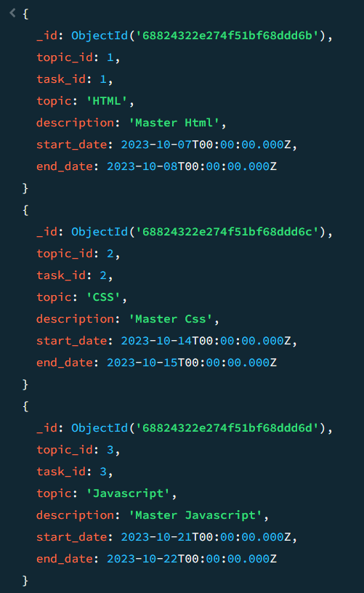

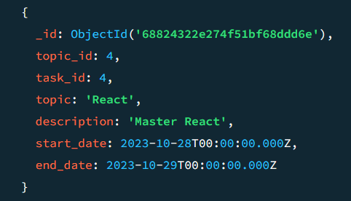

db.tasks.find({

deadline_date: { $gte: ISODate("2023-10-01"), $lte: ISODate("2023-10-31") }

})

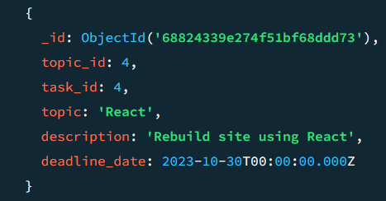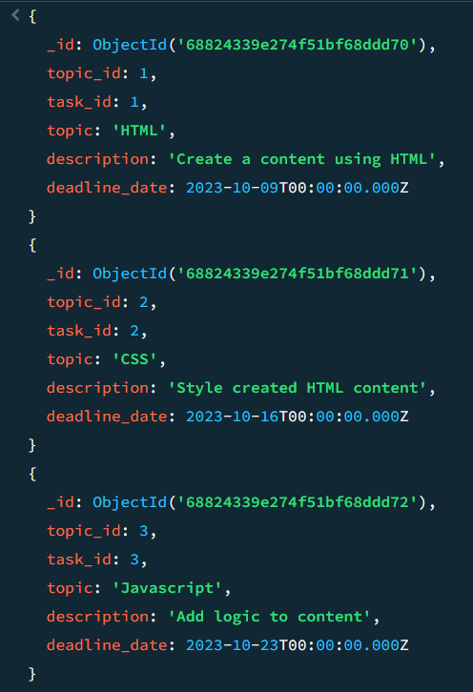

2.Find all the company drives which appeared between 15 oct-2023 and 31-oct-2023

db.companydrives.find({

drive_date: { $gte: ISODate("2023-10-15"), $lte: ISODate("2023-10-31") }

})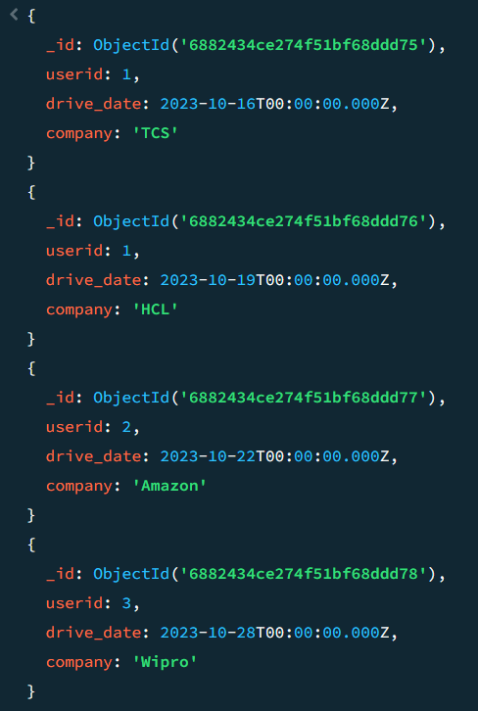

3.Find the number of problems solved by the user in codekata

db.codekata.aggregate([

{

$project: {

user_id: 1,

total_problems_solved: { $sum: ["$codekata_solved", "$webkata_solved"] }

}

}

])

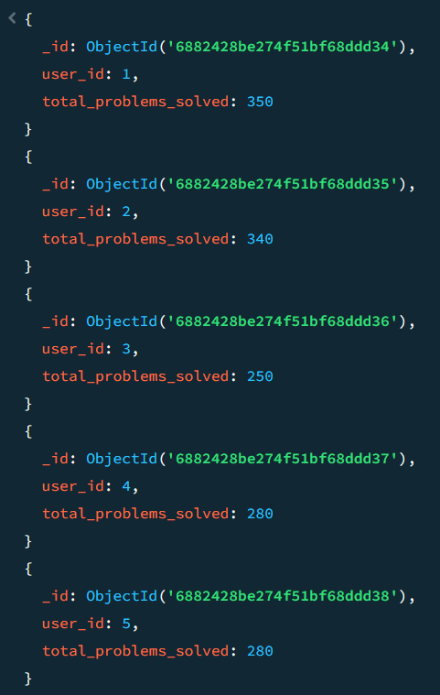

4.Find all the mentors with who has the mentee's count more than 15

db.mentors.find({

mentees: { $gt: 15 }

})

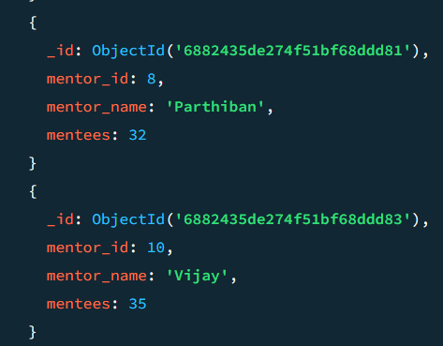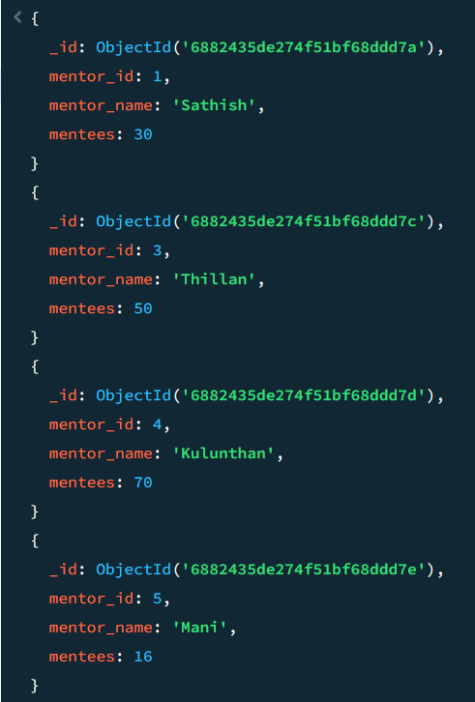

5.Find the number of users who are absent and task is not submitted between 15 oct-2023 and 31-oct-2023

const absentUsers = db.attendance.distinct("userid", {

Class_date: { $gte: ISODate("2023-10-15"), $lte: ISODate("2023-10-31") },

attendance: false

});

db.task_completion.aggregate([

{

$match: {

userid: { $in: absentUsers },

task_completion: false

}

},

{

$count: "users_absent_and_task_incomplete"

}

])

